2. OUTPUT SCREENSHOTS
FitTrack AI Backend Project

API Testing Output Screenshots
The following screenshots are taken from the original project document and show the API testing results using the project's API testing workflow.

Authentication API Testing
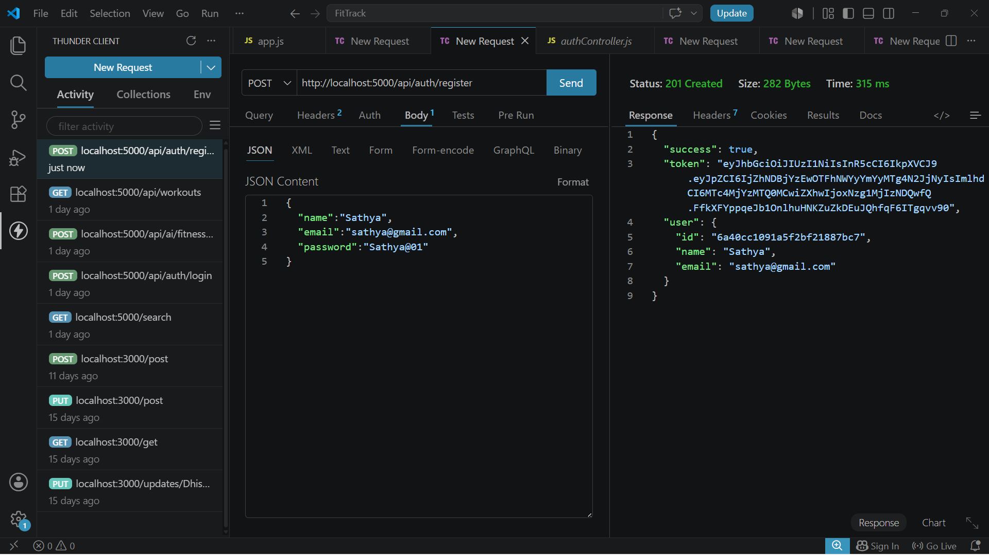
Login User

Get Profile

Workout API Testing

Add Workout

Get All Workouts

Get Workout By ID
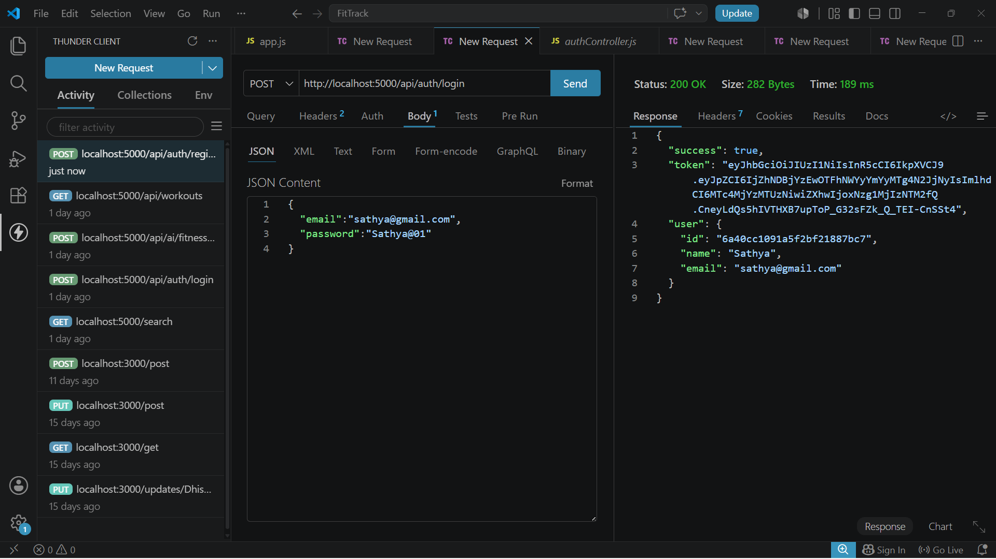
Update Workout

Delete Workout

AI API Testing

Workout Recommendation

Fitness Insights

